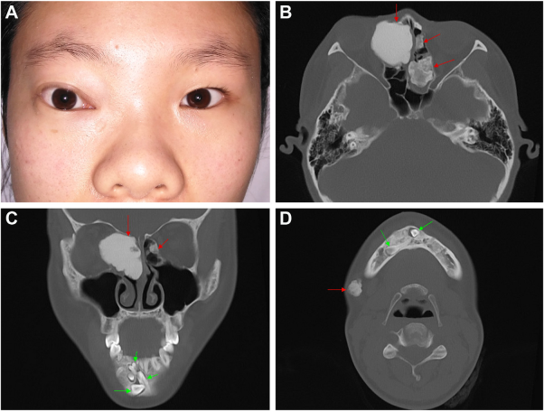

A 20-year-old woman presented with a 3-year history of progressive proptosis of the right eye (A). Her father had a history of multipleosteomas. Congenital hypertrophy of the retinal pigment epithelial was not found on retinal examination, except for retinal folds. Multiplewell-circumscribed masses of high radiodensity (B-D), and multiple unerupted supernumerary teeth (C-D) were observed on computedtomography. The osteomas of the right ethmoidal sinus wereremoved due to the threat of the intraorbital structure. Based on the provided images and clinical description please make an ophthalmic diagnosis for this patient. And output the diagnostic conclusions only.

**The ophthalmic diagnosis for this patient is orbital osteoma.**